

Floating Light Project in a Bottle

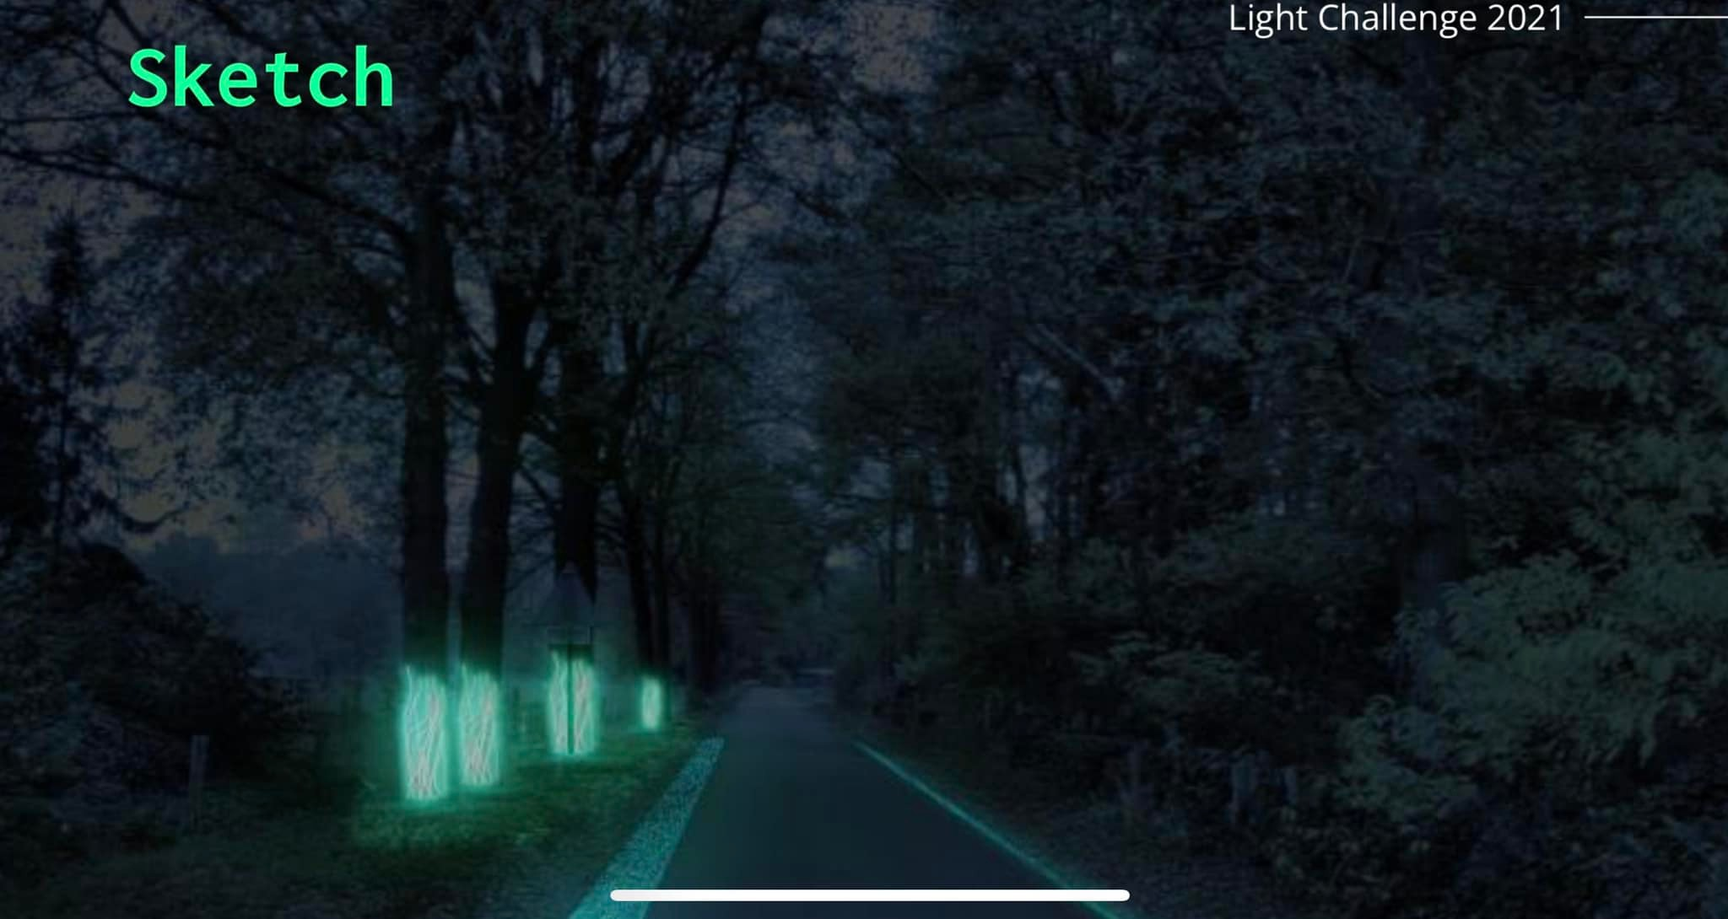

# Learning objectives

Students will learn to create a floating light project in a bottle using an LED blacklight, solar panel, Arduino, and tonic water. This project combines elements of renewable energy, programming, and chemistry. This interdisciplinary project aims to foster creativity, enhance technical skills, and provide a comprehensive understanding of how different scientific principles can be applied in a fun and engaging way. By the end of this project, students will have a unique, glowing bottle that demonstrates their newfound knowledge and skills.

**Introduction for Floating Light Project in a Bottle**

In this exciting and innovative project, students will embark on a journey to create a mesmerizing floating light in a bottle. Utilizing an LED blacklight, a solar panel, Battery an Arduino microcontroller, and tonic water, this project not only illuminates but also integrates key elements from various STAEM fields, including renewable energy, programming, and chemistry.

**Renewable Energy:** By incorporating a solar panel, students will explore the principles of converting sunlight into electrical energy, making the project environmentally friendly and sustainable.

**Programming:** Using an Arduino microcontroller, students will dive into the basics of programming, learning how to control the LED blacklight and create various lighting effects.

**Chemistry:** The use of tonic water introduces a fascinating chemical reaction, as the quinine in tonic water fluoresces under blacklight, producing a glowing effect.

B&T dimensions and types covered.

**Dimensions**:

* **Dimension 1: self-confidence in science and technology:** By building the item from scratch there is great confidence that is gathered.
* **Dimension 2: Confidence in technopolitical progress:** By combining hand-son actions creative elements and coding the students can build up confidence through small success, and then apply their skills to construct bigger items.
* **Dimension 3: Interest in new technology:** Students explore and engage with both technical and hands on activities depending on their creative proses.
* **Dimension 6: Technology can be learned:** This activity shows everyone that technology can be learned, by offering a fun activity that has interesting results.

**Type:**

* **Creative makers:** Interesting challenge for the creative maker. Engage with the putting together a technical aspect in a creative and technical manner.
* **Explorers:** This activity provides a safe, guided space to experiment and learn by trial and error. Testing materials for conductivity and discovering how coding and functional elements work together

Grade Level

high school / senior high school (grades 9/10–12) from 15 to 17/18 years old. Three groups of 4 students.

High School / College Level / Girls, Women 16 -30 Art, Design, Human tech. Four to five groups of 4 students.

Subjects

**Natural Sciences:** material properties.

**Technology:** coding

**Mathematics:** Measuring and classifying materials based on conductivity.

Materials

* LED blacklight
* Small solar panel
* Battery
* Arduino microcontroller
* Tonic water
* Clear plastic or glass bottle
* Waterproof sealant
* Wires and connectors
* Breadboard
* Resistors
* USB cable for Arduino
* Arduino IDE (installed on computers)
* Basic tools (screwdrivers, wire cutters, soldering iron)

**Safety Precaution** & **tips:**

* Beware of electric power

Duration

Session 1: Introduction to the Project and Assembly (1 hour)

Session 2: Programming the Arduino and Assembling the Circuit (1 hour)

Session 3: Final Assembly and Demonstration (1 hour)

Lesson Plan

Introduction

In a room or facilities where you can explain the different step-by-step developments.

step-by-step development

**Session 1: Introduction to the Project and Assembly (1 hour)**

**Step 1: Introduction (15 minutes)**

* Briefly explain the project and its components.
* Discuss the principles of renewable energy using a solar panel.
* Explain the role of Arduino in controlling the LED light.
* Introduce the concept of fluorescence and how tonic water will be used to create a glowing effect.

**Step 2: Preparing the Bottle (20 minutes)**

* Demonstrate how to clean and prepare the bottle.
* Pour tonic water into the bottle and seal it with a waterproof sealant.
* Test the bottle by shaking it to ensure it is properly sealed and no water leaks.

**Step 3: Setting Up the Solar Panel, Battery and Arduino (25 minutes)**

* Show how to connect the solar panel to the Arduino.
* Explain the importance of the correct polarity and how to use a multimeter to check connections.
* Connect the solar panel to a breadboard and then to the Arduino.

**Session 2: Programming the Arduino and Assembling the Circuit (1 hour)**

**Step 1: Introduction to Arduino IDE (15 minutes)**

* Introduce the Arduino IDE and basic programming concepts.
* Explain how to write and upload a simple program to the Arduino.

**Step 2: Writing the Code (30 minutes)**

* Provide the code to control the LED blacklight based on solar panel input. (downloads)
* Explain the code step-by-step.
* Assist students in uploading the code to their Arduinos.

**Step 3: Connecting the LED and Testing (15 minutes)**

* Demonstrate how to connect the LED blacklight to the Arduino using the breadboard and appropriate resistors.
* Test the setup to ensure the LED turns on and off based on the solar panel's input.

**Session 3: Final Assembly and Demonstration (1 hour)**

**Step 1: Finalizing the Assembly (20 minutes)**

* Help students place the LED blacklight inside the bottle or attach it securely to the outside.
* Bottle must be filled 2/3 whit tonic water and must be closed again.
* Ensure all connections are waterproof and secure. (see watertight solution download files)
* All the electronics can be placed in a box with the solar panels on top and filled whit the watertight solution after testing. There can be a floating device like some ping pong balls (min 2) include to hold the system in place.

**Step 2: Testing the Project (20 minutes)**

* Place the bottle in sunlight or under a strong light source to activate the solar panel.
* Observe the LED blacklight turning on and causing the tonic water to glow.
* Testing the floating abilities of the system by pouring tonic water in or out the bottle.
* Be sure that the solar panel is directed to the sunlight.

wrap- up & reflection

Finnish **Step 3: Discussion and Wrap-Up (20 minutes)**

* Discuss the outcome of the project and any challenges faced during assembly.
* Encourage students to think of improvements or variations they could make to the project.

Explain how the concepts learned can be applied to other projects involving renewable energy and microcontrollers.

Extension activities

* Experiment with different bottle shapes and sizes to see how it affects the light diffusion.
* Modify the code to include different lighting patterns or responses to varying light levels.
* Integrate additional sensors, such as a temperature or motion sensor, to create more interactive projects.
* It doesn’t have to be a floating device, as a standalone it works as well in the dark as a shiny blue light. Also works great in icy surroundings.

Additional Resources

Licht challenge <https://www.lightchallenge.eu/> lightshows in cities,

References:

https://www.arduino.cc/

Learning platform whit ideas and hardware

<https://www.streetlights-solar.com/solar-light-installation-guide.html>

Watertight solution

<https://www.amazon.nl/Elektrische-bruin-doorschijnend-doorzichtig-aansluitdozen-printplaten/dp/B0CRQDRNH8/ref=asc_df_B0CRQDRNH8/?tag=nlshogostdde-21&linkCode=df0&hvadid=710021896068&hvpos=&hvnetw=g&hvrand=15444915719292872722&hvpone=&hvptwo=&hvqmt=&hvdev=c&hvdvcmdl=&hvlocint=&hvlocphy=9103725&hvtargid=pla-2315338024554&psc=1&mcid=611848cfc4bc3a758a1e7d8d191a9b1e&gad_source=1>

Downloadable files

Here's the Arduino code example that sets up a basic circuit to manage a solar panel, battery, and LED, using the components below. The code will monitor the solar cells to determine when to turn the LED on or off based on the amount of light detected. It also takes into account the charge of the battery and ensures the LED operates only when there's enough power.

Note that this is a general setup. Ensure proper connections on the breadboard according to the specifications of each component.

cpp

Code copy

// Define pins

const int solarPin = A0; // Analog input to read voltage from the solar panel

const int ledPin = 9; // LED output pin

const int resistorPin = A1; // Pin to read current across R1

// Thresholds (Adjust as needed based on light conditions and desired functionality)

const int lightThreshold = 500; // Threshold for light intensity to turn LED on

const int batteryThreshold = 3.7; // Minimum battery voltage in volts to power LED

// Variables

float batteryVoltage = 0;

float solarVoltage = 0;

float currentThroughLED = 0;

void setup() {

pinMode(ledPin, OUTPUT);

Serial.begin(9600); // For debugging

}

void loop() {

// Read the voltage of the solar panel

solarVoltage = analogRead(solarPin) * (5.0 / 1023.0); // Convert analog reading to voltage

batteryVoltage = measureBatteryVoltage(); // Measure battery voltage

// Determine if the LED should be on or off based on light level and battery voltage

if (solarVoltage >= lightThreshold && batteryVoltage >= batteryThreshold) {

digitalWrite(ledPin, HIGH); // Turn on LED

} else {

digitalWrite(ledPin, LOW); // Turn off LED

}

// Measure current through LED

currentThroughLED = measureCurrentThroughR1();

// Debug output

Serial.print("Solar Voltage: ");

Serial.print(solarVoltage);

Serial.print(" V, Battery Voltage: ");

Serial.print(batteryVoltage);

Serial.print(" V, Current Through LED: ");

Serial.print(currentThroughLED);

Serial.println(" A");

delay(1000); // Update every second

}

float measureBatteryVoltage() {

// Simulate battery voltage measurement (connect battery voltage divider here if needed)

int batteryAnalog = analogRead(A2); // Assuming battery voltage is connected to A2 through a voltage divider

return batteryAnalog * (5.0 / 1023.0); // Convert analog reading to voltage

}

float measureCurrentThroughR1() {

int resistorVoltage = analogRead(resistorPin); // Voltage across R1

float voltageAcrossR1 = resistorVoltage * (5.0 / 1023.0);

return voltageAcrossR1 / 1.0; // I = V / R, with R1 = 1 Ω, so I = V

}

**Explanation of the Code**

1. **Solar Panel Voltage Measurement**: The code reads the voltage from the solar panel using an analog pin (solarPin) and calculates the voltage. This is used to determine the light level and if it meets the threshold (lightThreshold) to turn on the LED.
2. **Battery Voltage Measurement**: The measureBatteryVoltage function simulates reading the battery voltage. Ensure the battery is connected to an analog pin through a voltage divider for accurate reading.
3. **Current Measurement**: The code calculates the current through R1 by reading the voltage drop across it. Since R1 is a 1 Ω resistor, the current can be directly calculated.
4. **LED Control**: Based on the light level from the solar panel and battery voltage, the LED is turned on or off.

Make sure to adjust the lightThreshold and batteryThreshold values according to your setup. The code assumes a simple setup without complex power management. If you'd like, you could add further conditions for charging the battery from the solar cells when needed.

Example how to build a solar panel with battery and led.

4400mAh NiCd rechargeable battery,  
in the middle a breadboard and on the right side four small solar cells.

"R1 is a 1 Ω resistor. It is only used to measure the current through the circuit and the LED. (see below)  
R2 is a 560 kΩ resistor that controls the switching on and off of the LED depending on the light hitting the solar cells.  
PR4403 0,9 V Boost Driver  
C1 is a 470 µF capacitor.  
Z1 is a 1N5819 Schottky diode. (the right one ensures that the battery voltage does not pass over my solar cells)  
L1 is a 100 µH coil (its value determines the current through the LED)."